Chapter 16, Solution 61.

Find the voltage v_{o}(t) in the circuit of Fig. 16.84 by means of the Laplace transform.

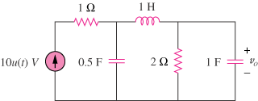

10u(t) V

+
−

Figure 16.84
For Prob. 16.61.

Solution

The s-domain version of the circuit is shown below.

1 s
V₁ V_{o} + 2/s 2 1/s
10/s
-

At node 1,

(1)

At node 2,

(2)

Substituting (2) into (1) gives

Use MATLAB to find the roots.

>> p=[1 2.5 4 3]

p =

1.0000 2.5000 4.0000 3.0000

>> r=roots(p)

r =

-0.6347 + 1.4265i
-0.6347 - 1.4265i
-1.2306

Thus,

Where A = 20/3 = 6.667; B =

or

v_{o}(t) = [6.667–6.8e^{–1.2306t}+2.904e^{–0.6347t}(e^{–(1.4265t+88.68˚)}+e^{(1.4265t+88.68˚)})]u(t) volts or

= [6.667–6.8e^{–1.2306t}+5.808e^{–0.6347t}cos(1.4265t+88.68˚)]u(t) V.

Answer does check for initial values and final values.

